**QSMART – CG CONNECTORS REPLACEMENT**

**PROCEDURE**

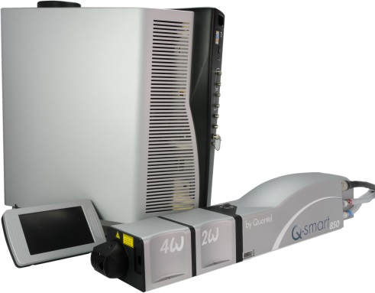

**Toolkit:**

Allen keys

**System**: QSMART

|  |  |  |  |  |  |  |  |  |
| --- | --- | --- | --- | --- | --- | --- | --- | --- |
| |  |  |  |  |  |  |  | | --- | --- | --- | --- | --- | --- | --- | | |  |  | | --- | --- | | 3/E10/0655 | **Q-SMART CG CONNECTOR** | |  |  |  |  | |  |

**Purpose**: This document details how to change the CG Connectors

|  |  |  |
| --- | --- | --- |
| Revision | date | modification |
| Initial issue | July 4, 2014 |  |
|  |  |  |
|  |  |  |
|  |  |  |

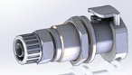

# DISASSEMBLY

* Open the ICE and the cooling group

*See procedure " CG - SM010355-COOLING GROUP ASSEMBLY "*

# INTEGRATION OF THE CONNECTORS

|  |  |  |
| --- | --- | --- |
| 0.01 | 3/E10/0440 | POLYETHYLENE TUBE 3/8 |
| 3.00 | 3/E10/0655 | CG CONNECTORS CPC APCD 12006 |
| 2.00 | 3/E10/0400 | RETAINING BRACKET JOHN GUEST PM2610S |

3/E10/0440 : 170mm

3/E10/0440 : 250mm

3/E10/0440 : 270mm

2X 3/E10/0400

30mm

20mm

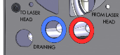

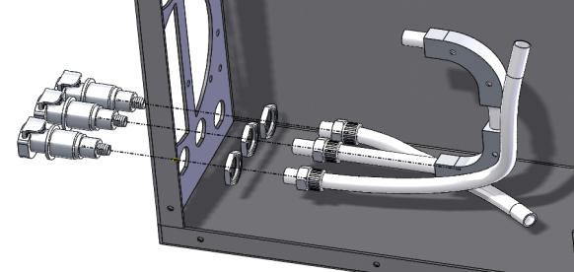

# TEST AND CLOSING

* Perform the test of CG and close.
* Close the ICE

*Refer to "CG-Test & closing" and "CG - SM010355-COOLING GROUP ASSEMBLY"*